Sentiment Analysis on

Customer Reviews
A MAJOR PROJECT REPORT
Submitted in partial fulfilment of the Requirement for the award of Bachelor of Computer Application Degree

LNCT UNIVERSITY, BHOPAL (M.P.)

SCHOOL OF COMPUTER SCIENCE & TECHNOLOGY (SOCST)
DEPARTMENT OF COMPUTER APPLICATION

BAI- 604, MAJOR PROJECT
Submitted by
Chetan Yadav (LNCCBCA31140)
Avish Porwal (LNCCBCA11145)
Jeet Yadav (LNCCBCA11167)
Saman Kushwaha (LNCCBCA21154)
Suryansh Dubey (LNCCBCA41147)
Under the guidance of
Prof. Aniket Satpute
BACHELOR OF COMPUTER APPLICATION

LNCT UNIVERSITY, BHOPAL

JANUARY-JUNE, 2025

CERTIFICATE
This is to certify that the work embodied in this BAI – 604, MAJOR PROJECCT (Based on Artificial Intelligence) has been satisfactory completed by Chetan Yadav (LNCCBCA31140), Avish Porwal (LNCCBCA11145), Jeet Yadav (LNCCBCA11167), Saman Kushwaha (LNCCBCA21154), Suryansh Dubey (LNCCBCA41147). It is a Bonafide piece of work, carried out under my guidance in the School of Computer Science & Technology, LNCT University, Bhopal for the partial fulfillment of the Bachelor of Computer Application degree during the academic session January-July, 2025.
Guided by

Prof. Aniket Satpute

Approved By

Head of Department

Forwarded by

Director

School of Computer Science & Technology LNCT University, Bhopal

CERTIFICATE OF APPROVAL

This foregoing BAI-604, MAJOR PROJECT is hereby approved as a creditable study of a Bachelor of Computer Application Subject carried out and presented in a manner satisfactory to warranty its acceptance as a prerequisite to the degree for which it has been submitted. It is understood that by this approval the undersigned do not necessarily endorse or approve any statement made, opinion expressed or conclusion drawn therein, but approve the thesis only for the purpose for which it has been submitted.

Internal Examiner External Examiner

DECLARATION

We, Chetan Yadav (LNCCBCA31140), Avish Porwal(LNCCBCA11145), Jeet Yadav (LNCCBCA11167), Saman Kushwaha(LNCCBCA21154), Suryansh Dubey(LNCCBCA41147) are students of School of Computer Science & Technology, LNCT University, Bhopal, hereby declare that the work presented in this BAI-604, MAJOR PROJECT is outcome of our own work has been carried out taking care of Engineering Ethics.
The work presented does not infringe any parented work has not been submitted to any University for the award of any degree or any professional diploma.

Chetan Yadav (LNCCBCA31140),
Avish Porwal (LNCCBCA11145),
Jeet Yadav (LNCCBCA11167),
Saman Kushwaha (LNCCBCA21154),
Suryansh Dubey (LNCCBCA41147)
Date: 03-05-2025

ACKNOWLEDGEMENT

We are thankful of the staff and faculty of LNCTU for providing us the knowledge and guidance for making the project successful. Project like this cannot be the efforts of a single person alone. Many people spread there helping hand to us during the entire process and We are thankful to all of them.
There is a great pleasure for us to make a project on “Sentiment Analysis on Customer Reviews”.
The timely completion of this project is mainly due to the interest and contribution of Prof. Aniket Satpute, who is not only our teacher but also a great guide. Without his help, the completion of this project would not have been possible.
We would also like to extend our gratitude to many other individuals at LNCT UNIVERSITY (BCA), who have contributed greatly the success of this project. Thanks are due to Dr. Sanjay Bajpai the director of LNCTU (BCA).
At last, but not the least we like to extend our thanks to our family and friends without blessing and support We wouldn’t have completed our project.

TABLE OF CONTENT

 | PAGE NO.
CHAPTER 1  - INTRODUCTION  - BACKGROUND OF THE STUDY  - PROBLEM STATEMENT  - THE SOLUTION | 1-4
CHAPTER 2 TECHNOLOGY USED  - FRONT END  - BACK END  - MODEL | 5-8
CHAPTER 3  - SOURCE CODE  - SCREEN SHOTS | 9-48
CHAPTER 4  - STEPS FOR TESTING | 49-50
CHAPTER 5  - CONCLUSION  - FUTURE SCOPE | 51-52
CHAPTER 6  - REFRENCES  - BIBLIOGRAPHY | 53-54

CHAPTER 1

INTRODUCTION

The primary goal of the Sentiment Analysis using Support Vector Machine (SVM) project is to deliver a fast, accurate, and reliable method for classifying textual data based on sentiment. We have developed this system to help organizations and individuals automatically determine whether a piece of text conveys a positive or negative sentiment, which is highly beneficial for applications such as product reviews, social media monitoring, customer feedback, and more.

Our solution employs a machine learning-based approach, specifically utilizing the Support Vector Machine algorithm, to process and analyze text data efficiently. By leveraging natural language processing (NLP) techniques, the system converts raw text into structured data through steps such as tokenization, vectorization, and feature extraction before classification.
This project addresses the challenges associated with manually analyzing large volumes of textual feedback, which can be time-consuming and prone to inconsistencies. With our model, sentiment can be identified automatically, enabling real-time insights and supporting quicker decision-making.
We have also focused on making the system scalable and interpretable. The implementation includes performance metrics such as accuracy, precision, recall, and confusion matrix analysis to evaluate the quality of predictions. The system can be extended or fine-tuned to accommodate multi-class sentiment categories, domain-specific text, or additional languages.

Our aim is to bridge the gap between human emotion and machine understanding, empowering digital platforms to respond more intelligently to user sentiment. This project ultimately promotes the integration of AI in language understanding tasks, enhancing data-driven strategies across industries like marketing, customer service, and social media analytics.
.

BACKGROUND OF THE STUDY

In today's digital era, vast amounts of textual data are generated daily through platforms such as social media, online reviews, blogs, and customer feedback systems. Extracting meaningful insights from this unstructured data is a growing challenge and an essential task for businesses, organizations, and researchers aiming to understand public opinion, improve services, and make data-driven decisions.
Traditionally, analyzing sentiments within text has been a manual and labor-intensive process prone to bias and inconsistency. With the increasing demand for real-time sentiment evaluation and the sheer volume of data being produced, there is a need for automated, scalable, and accurate sentiment analysis systems.

The advancement of Artificial Intelligence (AI), particularly in the field of Natural Language Processing (NLP), has enabled the development of models capable of understanding and interpreting human language with high precision. Support Vector Machines (SVMs), known for their effectiveness in classification problems, are well-suited for binary sentiment classification tasks such as distinguishing between positive and negative opinions.
In this project, we apply machine learning techniques to preprocess and vectorize text data, and then train an SVM classifier to determine the sentiment of each text entry. The system incorporates essential NLP steps such as data cleaning, tokenization, and feature extraction using techniques like TF-IDF, ensuring accurate representation of textual features.
The study demonstrates how classical machine learning models, when properly tuned and supported by robust preprocessing, can perform sentiment classification efficiently without requiring deep learning architectures. The simplicity, speed, and effectiveness of SVM make it a reliable choice for a wide range of sentiment analysis applications.

This project also includes visualization and performance metrics to evaluate the model’s accuracy and precision, providing insights into its real-world applicability. The system aims to enhance decision-making processes across domains such as marketing, customer support, politics, and content moderation by offering a practical and automated approach to sentiment understanding.

PROBLEM STATEMENT

With the rise of social media platforms like Twitter, customers now publicly express their experiences and opinions about services in real-time. Airlines, in particular, receive a high volume of feedback through tweets—ranging from praise to complaints about delays, cancellations, lost baggage, or poor customer service.

Manually monitoring and analyzing such vast streams of tweets is impractical, time-consuming, and susceptible to human error. This makes it difficult for airline companies to quickly respond to issues, track performance trends, and improve overall customer satisfaction.
To address this challenge, this project aims to build an automated sentiment analysis system that can classify tweets related to major U.S. airlines into three sentiment categories: positive, negative, and neutral. Furthermore, it goes a step further by identifying the underlying reasons for negative sentiments, such as flight delays, poor customer service, or baggage issues.

By leveraging Natural Language Processing (NLP) and a Support Vector Machine (SVM) classifier, the system efficiently processes text data, extracts meaningful features using techniques like TF-IDF, and accurately predicts sentiment. This enables real-time sentiment tracking and complaint categorization, offering airlines a powerful tool to understand customer feedback and improve their services.

The goal is to provide a scalable, accurate, and interpretable solution that not only classifies sentiment but also helps in pinpointing service areas that need immediate attention, ultimately contributing to enhanced customer experience and operational efficiency.

THE SOLUTION

To address the challenges of manually analyzing large volumes of customer feedback on social media, this project proposes an AI-powered sentiment analysis system that uses Support Vector Machine (SVM) for efficient and accurate text classification.

The solution involves building a machine learning pipeline that processes and classifies tweets related to major U.S. airlines into three sentiment categories: positive, negative, and neutral. Additionally, for tweets with negative sentiment, the system further categorizes them into specific complaint reasons such as flight delays, customer service issues, or baggage problems.

The project applies Natural Language Processing (NLP) techniques for preprocessing tasks including text cleaning, tokenization, stop-word removal, and vectorization using Term Frequency–Inverse Document Frequency (TF-IDF), which transforms raw text into meaningful numerical features suitable for classification.

The backend is developed using Python, handling data preprocessing, model training, evaluation, and prediction tasks. SVM is chosen for its robustness and high performance in binary and multiclass classification problems, particularly in high-dimensional spaces like text data.

Model performance is evaluated using metrics such as accuracy, precision, recall, and confusion matrix visualization, ensuring transparency and reliability of the results. The system is designed to be lightweight, interpretable, and effective in real-world sentiment monitoring scenarios.
This approach enables timely identification of common customer complaints and public opinion trends, equipping airline companies with actionable insights to improve their services, enhance customer satisfaction, and support data-driven decision-making.

FRONT END
CHAPTER 2 TECHNOLOGY USED

The frontend of the Sentiment Analysis system is designed to offer a clean, responsive, and user-friendly interface that allows users to input tweets, trigger sentiment classification, and view the results instantly.

Languages:
      - React: A popular JavaScript library for building interactive user interfaces.
      - Vite: A fast build tool that improves development experience and performance.

Tools & Libraries:
      - Axios: Used for making HTTP requests to communicate with the backend APIs.
      - Material UI: A React component library that offers ready-to-use, beautiful, and responsive UI components to enhance the user experience.

BACK END
The backend of the AI-Assisted Diagnosis of Skin Cancer system is responsible for handling image processing, running the deep learning model, and serving diagnostic results to the frontend.

Languages:
      - Python: The primary programming language used for backend development and machine learning model integration.

Frameworks & Libraries:
      - Flask: A lightweight web framework used to create RESTful APIs for communication between the frontend and backend.
      - Flask-Cors: Used to enable Cross-Origin Resource Sharing (CORS) for secure communication between the React frontend and Flask backend.

Machine Learning & Image Processing:
      - TensorFlow: Deep learning framework used for building and training the Convolutional Neural Network (CNN) model.
      - NumPy: Library used for numerical operations and array management during image preprocessing and model inference.
      - Pillow: Python Imaging Library (PIL) used for loading and processing image files.

Utilities:
      - io: Python library used for handling in-memory file operations.
      - os: Used for interacting with the operating system and managing file paths during image upload and model loading.

MODEL
The model is the core component of the Sentiment Analysis system, designed to classify tweets related to U.S. airlines into positive, negative, or neutral sentiments. Additionally, it identifies the reason behind negative sentiments when applicable. The following technologies and techniques were used in building and evaluating the model

Python:

Used as the primary programming language for data preprocessing, model development, and evaluation tasks.

Numpy:
Supports numerical computations and efficient array handling during data transformation and model operations.

Matplotlib and Seaborn:
Employed to visualize data trends, sentiment distributions, and model evaluation metrics like confusion matrices.

NLTK (Natural Level Toolikt):
Used for natural language preprocessing tasks such as tokenization, stop word removal, and text normalization (including stemming and lowercasing). This ensures the text data is clean and standardized before being used for training.

CNN (Convolutional Neural Network):
A CNN-based approach is used for feature extraction from dermoscopic images and classification into benign or malignant categories. The CNN automatically learns important visual patterns that help distinguish between different types of skin lesions.

Scikit -learn (sklearn):
Provides a wide range of machine learning algorithms and tools:
- Train-Test Split for splitting the dataset
- TF-IDF Vectorization for converting cleaned tweets into numerical feature vectors
- Support Vector Machine (SVM) for building the classification model due to its high performance with text data
- Decision Tree and Random Forest were also explored during experimentation
- Evaluation Metrics such as accuracy, confusion matrix, precision, recall, and F1-score for performance analysis

MLXtend:
Used to plot enhanced confusion matrices for better visualization and interpretation of the model's prediction results

    - CHAPTER 3

CHAPTER – 3

  - SOURCE CODE
WEB-DEVELOPMENT
mageDFS

MODEL

#importing req. Lib.
import pandas as pd
import numpy as np
import seaborn as sns
import matplotlib.pyplot as plt
import re
import nltk
from nltk.corpus import stopwords
from sklearn.model_selection import train_test_split
from mlxtend.plotting import plot_confusion_matrix
from sklearn.tree import DecisionTreeClassifier
from sklearn.ensemble import RandomForestClassifier
from sklearn.metrics import accuracy_score,confusion_matrix,classification_report
pip install mlxtend

#load our data set
data = pd.read_csv('Tweets.csv')
data.shape
#looking into our data
data.head()
#checking last 5 entries
data.tail()
#checking columns in our data
data.columns
#checking info our data
data.info()
#checking unique values
data.nunique()
#checking null values in our data
data.isnull().sum()
# **Preprocessing on data**
tweet_created column got the date recorts and showing type is object we have to change it of date time format
data['tweet_created'] = pd.to_datetime(data['tweet_created']).dt.date
data['tweet_created'] = pd.to_datetime(data['tweet_created'])
data.info()
data.head()
data['tweet_created'].min()
data['tweet_created'].max()
we have data from 16th feb 2015 to 25 feb 2015 mins we have data of 9 days.
#checking uniques values in tweet_created columns
data['tweet_created'].nunique()
numberoftweets = data.groupby('tweet_created').size()
numberoftweets.dtype
numberoftweets
here we can see tweets created every day
# **treating with null values**
data.isna().sum()
in
print("Percentage null or na values in df")
((data.isnull() | data.isna()).sum() * 100 / data.index.size).round(2)
**airline_sentiment_gold, negativereason_gold** have more than 99% missing data And **tweet_coord** have nearly 93% missing data. It will be better to delete these columns as they will not provide any constructive information
del data['tweet_coord']
del data['airline_sentiment_gold']
del data['negativereason_gold']
data.head()
freq = data.groupby('negativereason').size()
freq
we cant fill it will affect in bad way for example we have positive reviwe and we fill the values with mode that means with Customer Service Issue it is missmatch and can be affect on train model so we keep the data as it is.
# **EDA**
### **Count of Type of Sentiment**
counter = data.airline_sentiment.value_counts()
index = [1,2,3]
plt.figure(1,figsize=(12,6))
plt.bar(index,counter,color=['green','red','blue'])
plt.xticks(index,['negative','neutral','positive'],rotation=0)
plt.xlabel('Sentiment Type')
plt.ylabel('Sentiment Count')
plt.title('Count of Type of Sentiment')
### **Airline sentiments for each airline**
#checking differtent airlines we have
data['airline'].unique()
print("Total number of tweets for each airline \n ",data.groupby('airline')['airline_sentiment'].count().sort_values(ascending=False))
airlines= ['US Airways','United','American','Southwest','Delta','Virgin America']
plt.figure(1,figsize=(12, 12))
for i in airlines:
indices= airlines.index(i)
plt.subplot(2,3,indices+1)
new_df=data[data['airline']==i]
count=new_df['airline_sentiment'].value_counts()
Index = [1,2,3]
plt.bar(Index,count, color=['red', 'green', 'blue'])
plt.xticks(Index,['negative','neutral','positive'])
plt.ylabel('Mood Count')
plt.xlabel('Mood')
plt.title('Count of Moods of '+i)
Looks like people are not having pleasant flights these days. It is important to know which airline pleases their costumers the most and vice versa, so we sill be looking at the percentage of the negative reviews for each airline.
neg_tweets = data.groupby(['airline','airline_sentiment']).count().iloc[:,0]
total_tweets = data.groupby(['airline'])['airline_sentiment'].count()

my_dict = {'American':neg_tweets[0] / total_tweets[0],'Delta':neg_tweets[3] / total_tweets[1],'Southwest': neg_tweets[6] / total_tweets[2],
'US Airways': neg_tweets[9] / total_tweets[3],'United': neg_tweets[12] / total_tweets[4],'Virgin': neg_tweets[15] / total_tweets[5]}
perc = pd.DataFrame.from_dict(my_dict, orient = 'index')
perc.columns = ['Percent Negative']
print(perc)
ax = perc.plot(kind = 'bar', rot=0, colormap = 'Greens_r', figsize = (15,6))
ax.set_xlabel('Airlines')
ax.set_ylabel('Percentage of negative tweets')
plt.show()
* United, US Airways, American substantially get negative reactions.
* Tweets for Virgin America are the most balanced.
figure_2 = data.groupby(['airline', 'airline_sentiment']).size()
figure_2.unstack().plot(kind='bar', stacked=True, figsize=(15,10))
print(figure_2)
### **Last but not least, people complain for many reasons about their flights; 10 reasons to be specific**
negative_reasons = data.groupby('airline')['negativereason'].value_counts(ascending=True)
negative_reasons.groupby(['airline','negativereason']).sum().unstack().plot(kind='bar',figsize=(22,12))
plt.xlabel('Airline Company')
plt.ylabel('Number of Negative reasons')
plt.title("The number of the count of negative reasons for airlines")
plt.show()
### What are the reasons for negative sentimental tweets for each airline ?
We will explore the negative reason column of our dataframe to extract conclusions about negative sentiments in the tweets by the customers
#get the number of negative reasons
data['negativereason'].nunique()

NR_Count=dict(data['negativereason'].value_counts(sort=False))
def NR_Count(Airline):
if Airline=='All':
a=data
else:
a=data[data['airline']==Airline]
count=dict(a['negativereason'].value_counts())
Unique_reason=list(data['negativereason'].unique())
Unique_reason=[x for x in Unique_reason if str(x) != 'nan']
Reason_frame=pd.DataFrame({'Reasons':Unique_reason})
Reason_frame['count']=Reason_frame['Reasons'].apply(lambda x: count[x])
return Reason_frame
def plot_reason(Airline):

a=NR_Count(Airline)
count=a['count']
Index = range(1,(len(a)+1))
plt.bar(Index,count, color=['red','yellow','blue','green','black','brown','gray','cyan','purple','orange'])
plt.xticks(Index,a['Reasons'],rotation=90)
plt.ylabel('Count')
plt.xlabel('Reason')
plt.title('Count of Reasons for '+Airline)

plot_reason('All')
plt.figure(2,figsize=(13, 13))
for i in airlines:
indices= airlines.index(i)
plt.subplot(2,3,indices+1)
plt.subplots_adjust(hspace=0.9)
plot_reason(i)
* Customer Service Issue is the main neagtive reason for US Airways,United,American,Southwest,Virgin America
* Late Flight is the main negative reason for Delta
* Interestingly, Virgin America has the least count of negative reasons (all less than 60)
* Contrastingly to Virgin America, airlines like US Airways,United,American have more than 500 negative reasons (Late flight, Customer Service Issue)
## **Is there a relationship between negative sentiments and date?**
It will be interesting to see if the date has any effect on the sentiments of the tweets(especially negative !). We can draw various coclusions by visualizing this.
date = data.reset_index()
#convert the Date column to pandas datetime
date.tweet_created = pd.to_datetime(date.tweet_created)
#Reduce the dates in the date column to only the date and no time stamp using the 'dt.date' method
date.tweet_created = date.tweet_created.dt.date
date.tweet_created.head()
df = date
day_df = df.groupby(['tweet_created','airline','airline_sentiment']).size()
# day_df = day_df.reset_index()
day_df
plot this and get better visualization for negative tweets.
day_df = day_df.loc(axis=0)[:,:,'negative']

#groupby and plot data
ax2 = day_df.groupby(['tweet_created','airline']).sum().unstack().plot(kind = 'bar', color=['red', 'green', 'blue','yellow','purple','orange'], figsize = (15,6), rot = 70)
labels = ['American','Delta','Southwest','US Airways','United','Virgin America']
ax2.legend(labels = labels)
ax2.set_xlabel('Date')
ax2.set_ylabel('Negative Tweets')
plt.show()
* Interestingly, American has a sudden upsurge in negative sentimental tweets on 2015-02-23, which reduced to half the very next day 2015-02-24. (I hope American is doing better these days and resolved their Customer Service Issue as we saw before)
* Virgin America has the least number of negative tweets throughout the weekly data that we have. It should be noted that the total number of tweets for Virgin America was also significantly less as compared to the rest airlines, and hence the least negative tweets.
* The negative tweets for all the rest airlines is slightly skewed towards the end of the week !
## **Wordcloud for positive reasons**
from wordcloud import WordCloud,STOPWORDS
pip install wordcloud
new_df=data[data['airline_sentiment']=='positive']
words = ' '.join(new_df['text'])
cleaned_word = " ".join([word for word in words.split()
if 'http' not in word
and not word.startswith('@')
and word != 'RT'
])
wordcloud = WordCloud(stopwords=STOPWORDS,
background_color='black',
width=3500,
height=2900
).generate(cleaned_word)
plt.figure(1,figsize=(12, 12))
plt.imshow(wordcloud)
plt.axis('off')
plt.show()
Wordcloud for Negative sentiments of tweets
new_df=data[data['airline_sentiment']=='negative']
words = ' '.join(new_df['text'])
cleaned_word = " ".join([word for word in words.split()
if 'http' not in word
and not word.startswith('@')
and word != 'RT'
])
wordcloud = WordCloud(stopwords=STOPWORDS,
background_color='black',
width=1500,
height=1450
).generate(cleaned_word)
plt.figure(1,figsize=(12, 12))
plt.imshow(wordcloud)
plt.axis('off')
plt.show()
### **Dropng the rows with neutral sentiments**
data.drop(data.loc[data['airline_sentiment']=='neutral'].index, inplace=True)
## **label encoding on airline_sentiment**
from sklearn.preprocessing import LabelEncoder

le = LabelEncoder()
le.fit(data['airline_sentiment'])

data['airline_sentiment_encoded'] = le.transform(data['airline_sentiment'])
data.head()
## **Preprocessing the tweet text data**
Now, we will clean the tweet text data and apply classification algorithms on it
def tweet_to_words(tweet):
letters_only = re.sub("[^a-zA-Z]", " ",tweet)
words = letters_only.lower().split()
stops = set(stopwords.words("english"))
meaningful_words = [w for w in words if not w in stops]
return( " ".join( meaningful_words ))
nltk.download('stopwords')
data['clean_tweet']=data['text'].apply(lambda x: tweet_to_words(x))
# **Vectorization**
x = data.clean_tweet
y = data.airline_sentiment

print(len(x), len(y))
### The data is split in the standard 80,20 ratio
x_train, x_test, y_train, y_test = train_test_split(x, y, random_state=42)
print(len(x_train), len(y_train))
print(len(x_test), len(y_test))
from sklearn.feature_extraction.text import CountVectorizer

# instantiate the vectorizer
vect = CountVectorizer()
vect.fit(x_train)
# Use the trained to create a document-term matrix from train and test sets
x_train_dtm = vect.transform(x_train)
x_test_dtm = vect.transform(x_test)
vect_tunned = CountVectorizer(stop_words='english', ngram_range=(1,2), min_df=0.1, max_df=0.7, max_features=100)
vect_tunned
# **Model Building**
#training SVM model with linear kernel
#Support Vector Classification-wrapper around SVM
from sklearn.svm import SVC
model = SVC(kernel='linear', random_state = 10)
model.fit(x_train_dtm, y_train)
#predicting output for test data
pred = model.predict(x_test_dtm)
#accuracy score
accuracy_score(y_test,pred)
#building confusion matrix
cm = confusion_matrix(y_test, pred)
cm
#defining the size of the canvas
plt.rcParams['figure.figsize'] = [15,8]
#confusion matrix to DataFrame
conf_matrix = pd.DataFrame(data = cm,columns = ['Predicted:0','Predicted:1',], index = ['Actual:0','Actual:1',])
#plotting the confusion matrix
sns.heatmap(conf_matrix, annot = True, fmt = 'd', cmap = 'Paired', cbar = False,linewidths = 0.1, annot_kws = {'size':25})
plt.xticks(fontsize = 20)
plt.yticks(fontsize = 20)
plt.show()

print(classification_report(y_test,pred))

* As we you can see above we have plotted the confusion matrix for predicted sentiments and actual sentiments (negative and positive)
* SVM Classifier gives us the best accuracy score i.e 91% precision scores according to the classification report.
* The confusion matrix shows the TP,TN,FP,FN for sentiments(negative, positive)

- MAIN:
import { StrictMode } from 'react'
import { createRoot } from 'react-dom/client' import App from './App.jsx'

createRoot(document.getElementById('root')).render(
<StrictMode>
<App />
</StrictMode>,

)

import js from '@eslint/js' import globals from 'globals'
- CONFIGURATION:

import react from 'eslint-plugin-react'
import reactHooks from 'eslint-plugin-react-hooks' import reactRefresh from 'eslint-plugin-react-refresh'

export default [
{ ignores: ['dist'] },
{
files: ['**/*.{js,jsx}'], languageOptions: { ecmaVersion: 2020, globals: globals.browser, parserOptions: {
ecmaVersion: 'latest', ecmaFeatures: { jsx: true }, sourceType: 'module',
},
},
settings: { react: { version: '18.3' } }, plugins: {
react,
'react-hooks': reactHooks, 'react-refresh': reactRefresh,
},
rules: {
...js.configs.recommended.rules,
...react.configs.recommended.rules,

...react.configs['jsx-runtime'].rules,
...reactHooks.configs.recommended.rules, 'react/jsx-no-target-blank': 'off',
'react-refresh/only-export-components': [ 'warn',
{ allowConstantExport: true },
],
},
},
]
- INDEX:
<!doctype html>
<html lang="en">
<head>
<meta charset="UTF-8" />
<link rel="icon" type="image/png" href="hospital dr logo.png" />
<meta name="viewport" content="width=device-width, initial-scale=1.0" />
<title>DermaDx</title>
</head>
<body>
<div id="root"></div>
<script type="module" src="/src/main.jsx"></script>
</body>
</html>
- PACKAGE:

{
"name": "frontend", "private": true, "version": "0.0.0",
"type": "module", "scripts": { "dev": "vite",
"build": "vite build", "lint": "eslint .", "preview": "vite preview"
},
"dependencies": { "@emotion/react": "^11.14.0", "@emotion/styled": "^11.14.0", "@mui/material": "^6.4.5",

"axios": "^1.7.9",
"react": "^19.0.0",
"react-dom": "^19.0.0"
},
"devDependencies": { "@eslint/js": "^9.19.0",
"@types/react": "^19.0.8",
"@types/react-dom": "^19.0.3", "@vitejs/plugin-react": "^4.3.4", "eslint": "^9.19.0",
"eslint-plugin-react": "^7.37.4", "eslint-plugin-react-hooks": "^5.0.0",
"eslint-plugin-react-refresh": "^0.4.18", "globals": "^15.14.0",
"vite": "^6.1.0"
}
}

- BACK-END

from flask import Flask, request, jsonify from flask_cors import CORS
import numpy as np
import tensorflow.lite as tflite # TFLite Interpreter from PIL import Image
import io import os

# Initialize Flask app app = Flask( name )
CORS(app) # Enable CORS for all routes
- APP

# Load TensorFlow Lite model try:
interpreter = tflite.Interpreter(model_path="model.tflite") interpreter.allocate_tensors()
input_details = interpreter.get_input_details() output_details = interpreter.get_output_details()
input_shape = input_details[0]['shape'][1:3] # Detect expected input size
print(f"⬛ TFLite Model loaded successfully! Expected input size: {input_shape}") except Exception as e:

print(f"+ Error loading TFLite model: {e}") interpreter = None

# Class labels & explanations CLASS_INFO = {
0: {"name": "Actinic keratosis", "explanation": "Suraj ki zyada roshni se hone wali chamdi ki samasya, jo future me cancer ban sakti hai.", "risk": "High Risk"},
1: {"name": "Basal cell carcinoma", "explanation": "Sabse common skin cancer, jo dheere-dheere badhta hai aur zyada khatarnak nahi hota.", "risk": "Medium Risk"},
2: {"name": "Benign keratosis", "explanation": "Chamdi ka ek nuksaan jo cancer nahi hai, par dikhta hai jaise ho sakta hai.", "risk": "Low Risk"},
3: {"name": "Dermatofibroma", "explanation": "Ek chhoti, hard, aur be-nuksaan wali chamdi ki ganth, jo generally safe hoti hai.", "risk": "Low Risk"},
4: {"name": "Melanoma", "explanation": "Sabse dangerous skin cancer, jo jaldi failta hai aur jaanleva ho sakta hai.", "risk": "High Risk"},
5: {"name": "Nevus", "explanation": "Simple mole ya til jo zyada tar nuksaan nahi karta.", "risk": "Low Risk"}, 6: {"name": "Squamous cell carcinoma", "explanation": "Ek doosra common skin cancer jo basal cell se thoda
zyada aggressive hota hai.", "risk": "High Risk"},
7: {"name": "Vascular lesion", "explanation": "Khoon ki naaliyo se judi chamdi ki problem, jo zyada tar harmful nahi hoti.", "risk": "Low Risk"},
8: {"name": "No Cancer", "explanation": "Koi bhi cancer nahi hai, aap safe ho! ⬛ ", "risk": "No Risk"}
}

# Image preprocessing function def preprocess_image(image):
try:
image = image.convert("RGB") # Ensure RGB format
image = image.resize(input_shape) # Resize to model's input shape image = np.array(image, dtype=np.float32) / 255.0 # Normalize image = np.expand_dims(image, axis=0) # Add batch dimension return image
except Exception as e:
print(f"+ Error in image preprocessing: {e}") return None

# TFLite Prediction Function def predict_tflite(image):
try:
image = preprocess_image(image) if image is None:
return None

interpreter.set_tensor(input_details[0]['index'], image) interpreter.invoke()
prediction = interpreter.get_tensor(output_details[0]['index'])

predicted_class = int(np.argmax(prediction, axis=1)[0]) # Get class index confidence = float(np.max(prediction)) # Get confidence score
return predicted_class, confidence except Exception as e:
print(f"+ Error in prediction: {e}") return None

# Define API route for predictions @app.route("/predict", methods=["POST"]) def predict():
if "file" not in request.files:
return jsonify({"error": "No file uploaded"}), 400 file = request.files["file"]
try:
image = Image.open(io.BytesIO(file.read())) result = predict_tflite(image)

if result is None:
return jsonify({"error": "Prediction failed"}), 500

predicted_class, confidence = result
disease_info = CLASS_INFO.get(predicted_class, {"name": "Unknown Condition", "explanation": "No details available.", "risk": "Unknown"})

# Recommendation based on risk level recommendation = ""
if disease_info["risk"] == "High Risk":
recommendation = " ı. Jaldi se dermatologist se consult karein!" elif disease_info["risk"] == "Medium Risk":
recommendation = "•˙Q Nazar rakhein, agar badlav aaye toh doctor se milna zaroori hai." else:
recommendation = "⬛ Aap safe hain, lekin regular checkup achha hota hai." return jsonify({

"disease": disease_info["name"], "explanation": disease_info["explanation"],
"confidence": f"{confidence * 100:.2f}%", # Convert to percentage "risk_level": disease_info["risk"],
"recommendation": recommendation
})

except Exception as e:
print(f"+ Error in prediction: {e}")
return jsonify({"error": "Prediction failed"}), 500

if name == " main ":
port = int(os.environ.get("PORT", 5000)) # Default port 5000 app.run(host="0.0.0.0", port=port, debug=True)
- CONVERT TO TLIFTE
import tensorflow as tf
model = tf.keras.models.load_model("model.h5")
converter = tf.lite.TFLiteConverter.from_keras_model(model) converter.optimizations = [tf.lite.Optimize.DEFAULT] # Optimize for size & speed tflite_model = converter.convert()
with open("model.tflite", "wb") as f: f.write(tflite_model)
print("⬛ Model converted to TFLite successfully!")

- MODEL

import os import cv2
import pandas as pd import numpy as np
import matplotlib.pyplot as plt import seaborn as sns
from sklearn.model_selection import train_test_split from sklearn.preprocessing import LabelEncoder
from tensorflow.keras.preprocessing.image import ImageDataGenerator import keras
from keras.callbacks import EarlyStopping,ModelCheckpoint import tensorflow as tf
from sklearn.metrics import confusion_matrix from sklearn.metrics import classification_report

from tqdm import tqdm
from imblearn.over_sampling import SMOTE
from sklearn.model_selection import train_test_split

In [2]:
def data(dataset_path): images = []
labels = []
for folder in os.listdir(dataset_path):
subfolder_path = os.path.join(dataset_path, folder) for subfolder in os.listdir(subfolder_path):
subfolder_path1 = os.path.join(subfolder_path, subfolder) if not os.path.isdir(subfolder_path):
continue
for image_filename in os.listdir(subfolder_path1): if image_filename.endswith(".jpg"):
image_path = os.path.join(subfolder_path1, image_filename) images.append(image_path)
labels.append(subfolder)
df = pd.DataFrame({'image': images, 'label': labels}) return df
In [3]:
#train
train=data('/kaggle/input/skin-cancer9-classesisic/Skin cancer ISIC The International Skin Imaging Collaboration')
train.head()

OUTPUT:
 | image | label
0 | /kaggle/input/skin-cancer9-classesisic/Skin ca... | pigmented benign keratosis
1 | /kaggle/input/skin-cancer9-classesisic/Skin ca... | pigmented benign keratosis
2 | /kaggle/input/skin-cancer9-classesisic/Skin ca... | pigmented benign keratosis
3 | /kaggle/input/skin-cancer9-classesisic/Skin ca... | pigmented benign keratosis
4 | /kaggle/input/skin-cancer9-classesisic/Skin ca... | pigmented benign keratosis

In [4]:
plt.figure(figsize=(15,5))
ax = sns.countplot(x=train.label) ax.set_xlabel("Class")

OUTPUT:
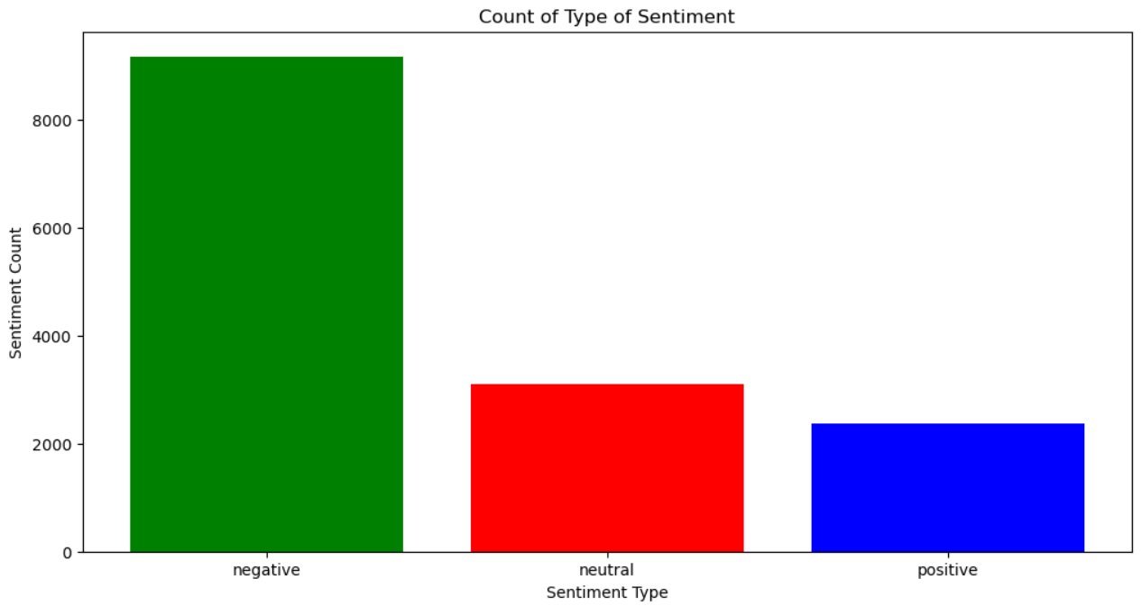
#Airline sentiments for each airline
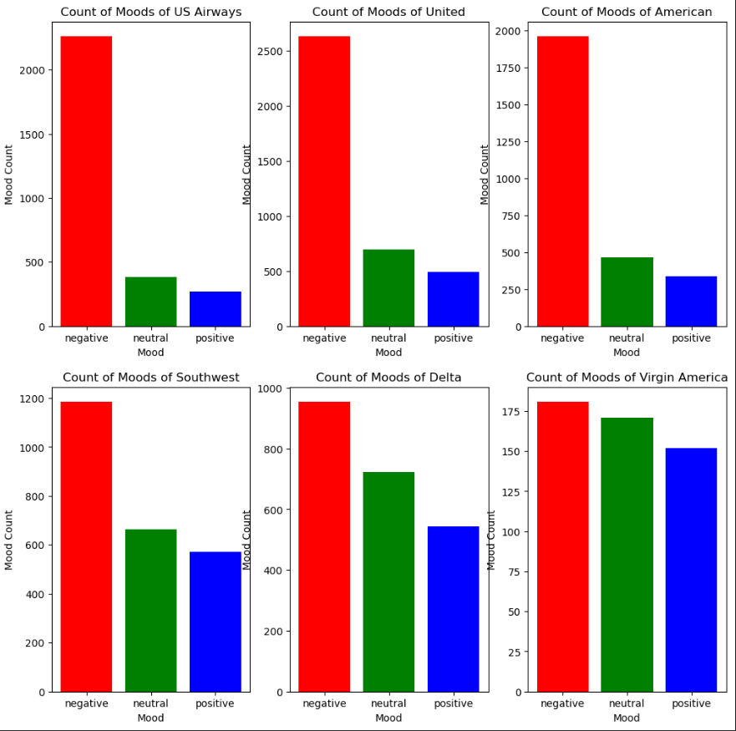

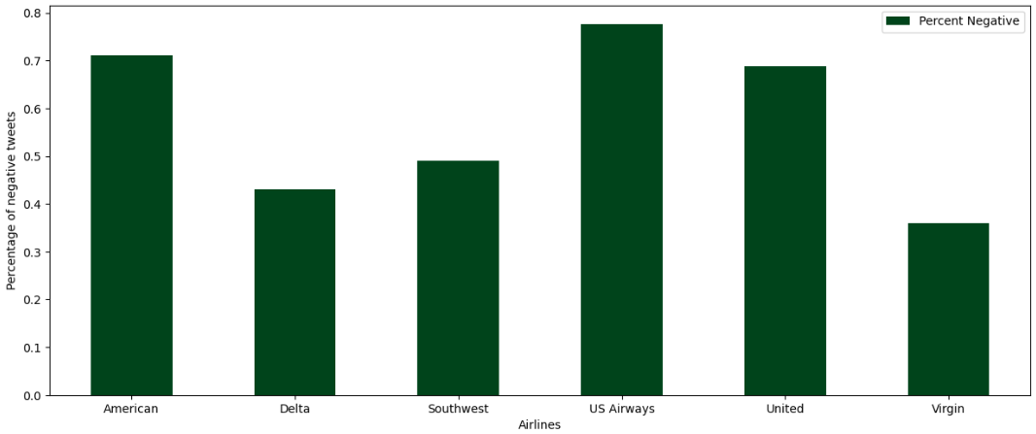

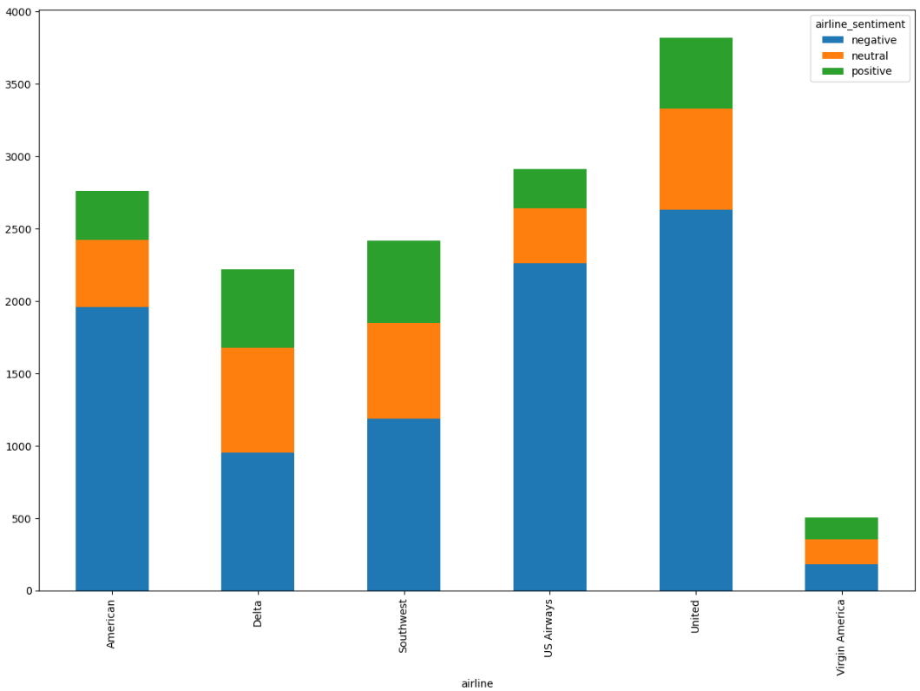

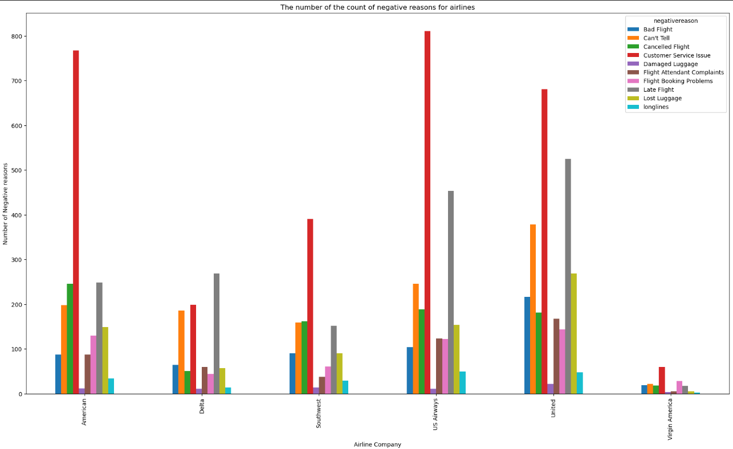

#get the number of negative reasons
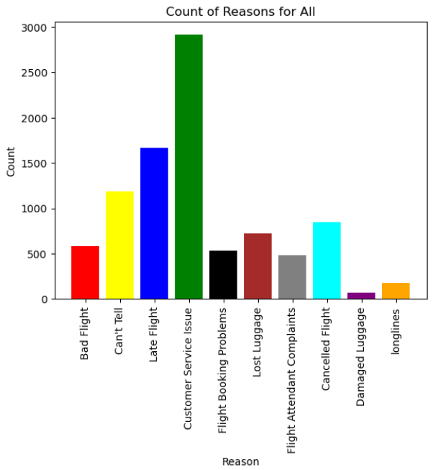
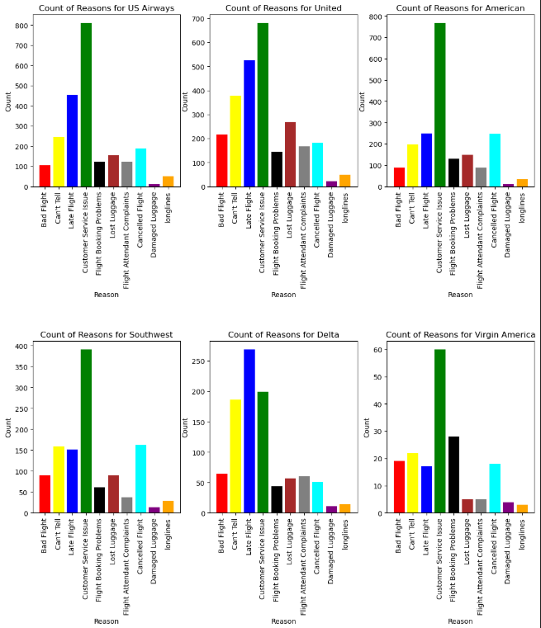

## relationship between negative sentiments and date
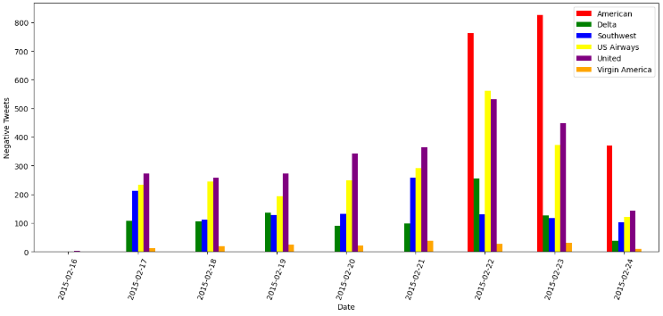

#WordCloud

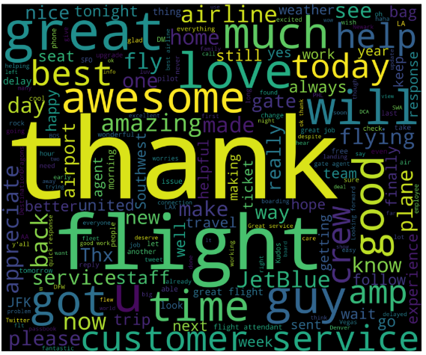
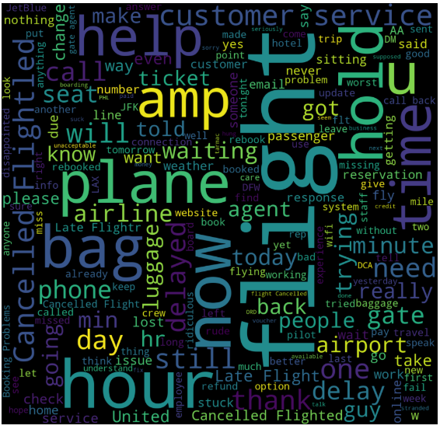

#plotting the confusion matrix

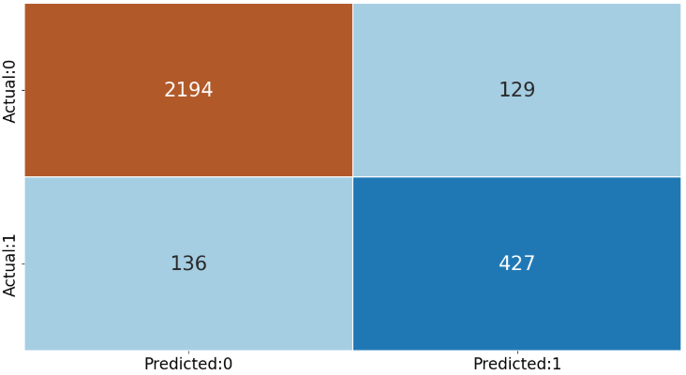

OUTPUT:

Web dev photo

  - SCREEN SHOTS
- INTERFACE:
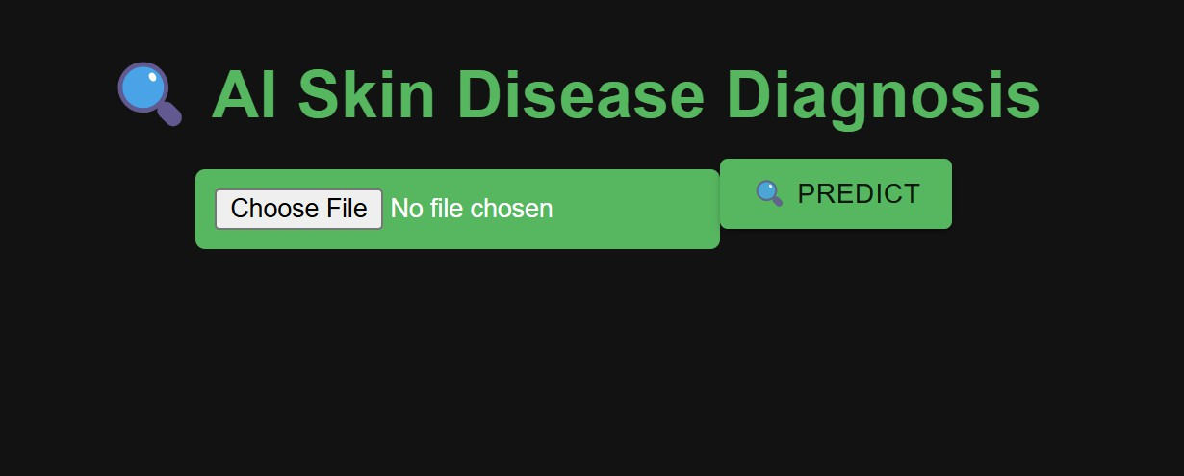
- FILE UPLOAD:
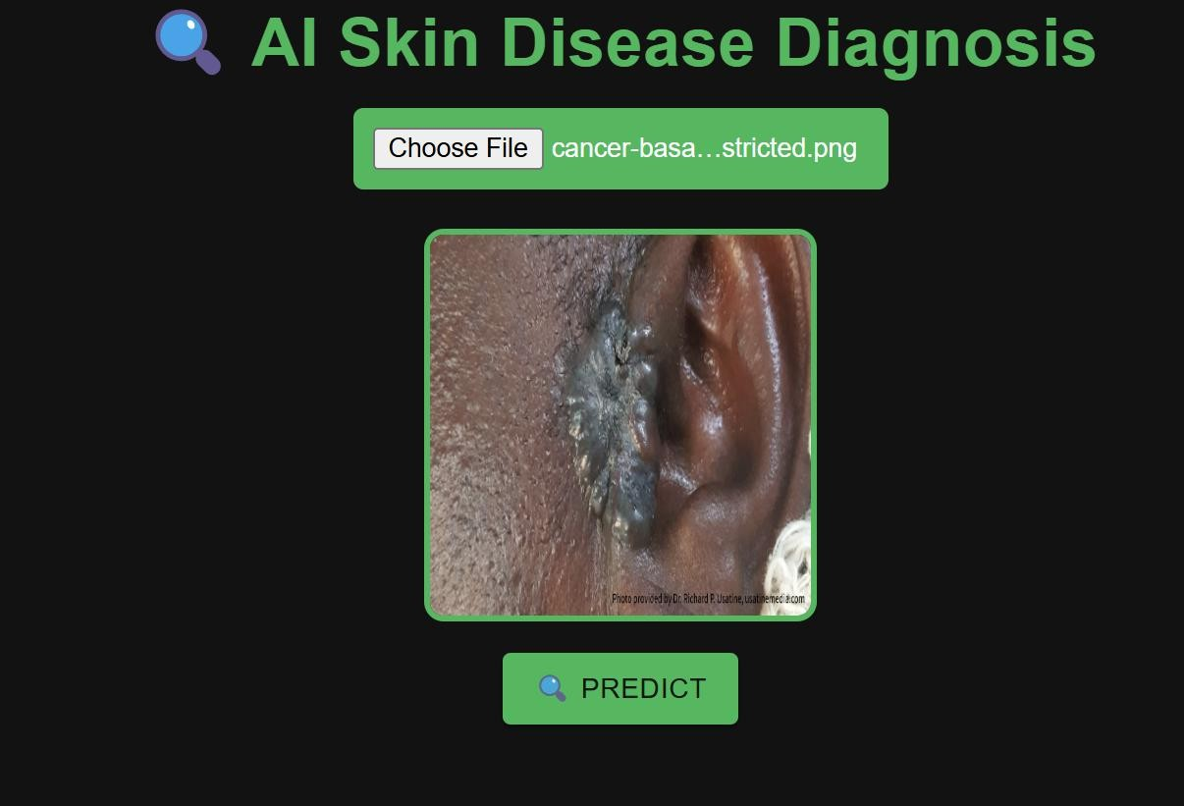

- AFTER FILE UPLOAD INTERFACE:

- AFTER UPLOAD PREDICTION:
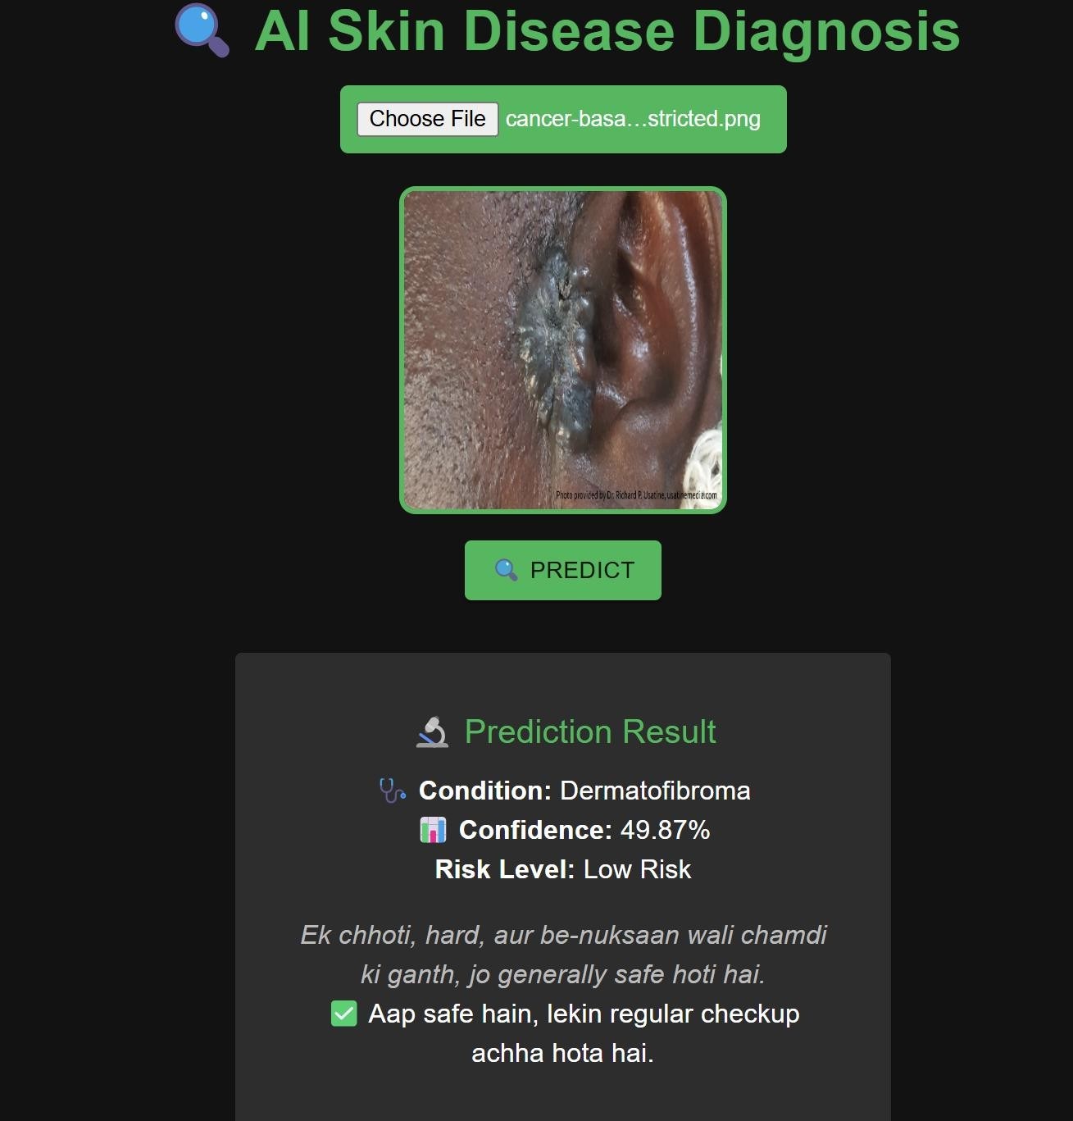

CHAPTER 4
  - STEPS FOR TESTING:
- OPEN DIAGNOSIS AI:WEBSITE KA PHOTO
- UPLOAD IMAGE:

- CLICK PREDICT:

- RESULT:

CHAPTER 5
  - CONCLUSION
The project "AI-Assisted Diagnosis of Skin Cancer" successfully demonstrates the potential of artificial intelligence and deep learning in enhancing early detection and classification of skin cancer.
By leveraging Convolutional Neural Networks (CNNs) and Transfer Learning with DenseNet121, the system provides an efficient, reliable, and non-invasive diagnostic tool that classifies dermoscopic images into benign and malignant categories with promising accuracy.
The integration of technologies such as TensorFlow, Keras, Flask, and React has enabled the creation of a complete end-to-end system that allows users to upload skin lesion images and receive instant predictions through a user-friendly interface.
Preprocessing techniques, data augmentation, and the application of SMOTE for balancing
datasets have further contributed to improving the model’s robustness and accuracy.
This project addresses the critical challenges associated with traditional skin cancer diagnosis methods, such as delays, costs, and dependency on expert availability, by offering an automated, scalable, and accessible solution.
It emphasizes the growing importance of AI in healthcare and illustrates how intelligent systems can support medical professionals in making faster and more accurate decisions.
The successful implementation of this project marks a significant step toward integrating AI into clinical practices and highlights its potential to revolutionize dermatological diagnosis and improve patient outcomes globally.

  - FUTURE SCOPE
While the AI-Assisted Diagnosis of Skin Cancer project has achieved significant success, there are multiple opportunities for further improvements and advancements to enhance its real-world applicability.

Enhancing Model Accuracy:
Future work can focus on experimenting with more advanced deep learning architectures, fine-tuning hyperparameters, and training the model with larger and more diverse datasets to further improve accuracy and reliability.

Expanding Dataset Diversity:
Incorporating datasets containing images from varied demographics, skin tones, and lesion types will enable the model to generalize better across different populations and skin conditions.

Real-time Diagnosis:
The system can be developed into a fully functional real-time mobile or web-based application, allowing users and medical professionals to receive instant diagnosis support even in remote or under-resourced areas.

Integration with Electronic Health Records (EHR):
Integrating the AI model with Electronic Health Records (EHR) systems can provide a more comprehensive overview of a patient's history, improving diagnostic accuracy and personalized treatment planning.

Explainable AI (XAI) Techniques:
Future versions can incorporate explainability methods, such as heatmaps or Grad-CAM visualizations, to highlight the specific areas of the lesion that influenced the model's decision, building trust among healthcare providers and patients.

Multi-class Classification and Risk Prediction:
Extending the model’s capabilities to classify multiple skin disease categories and predict the
potential risk level could provide even greater assistance to dermatologists.

Deployment on Low-resource Devices:
Optimizing the model for deployment on low-power devices such as smartphones or edge devices can expand accessibility, particularly in areas with limited internet or clinical facilities.

CHAPTER 6
  - REFRENCES
    - TensorFlow Official Documentation - Deep learning framework used for model development.
    - Keras Official Documentation - High-level neural networks API used for building CNN models.
    - Flask Official Documentation - Web framework used for backend development.
    - React.js Official Documentation - Frontend library used for user interface development.
    - Documentation and usage guidelines for Python libraries like OpenCV, Pandas, NumPy, Matplotlib, Seaborn, and scikit-learn.

  - BIBLIOGRAPHY
TensorFlow. (n.d.). TensorFlow Machine Learning Framework Documentation. Retrieved from https://www.tensorflow.org/
Keras. (n.d.). Keras API Reference Documentation. Retrieved from https://keras.io/
Flask. (n.d.). Flask Web Framework Documentation. Retrieved from https://flask.palletsprojects.com/
React.js. (n.d.). React – A JavaScript Library for Building User Interfaces. Retrieved from https://reactjs.org/
Scikit-learn. (n.d.). Machine Learning in Python Documentation. Retrieved from https://scikit-learn.org/

